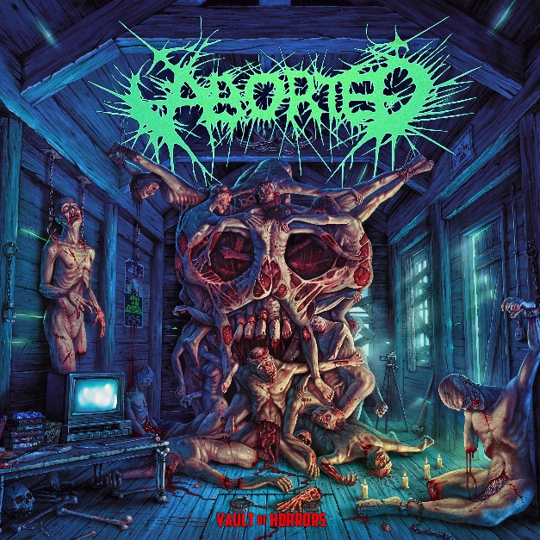
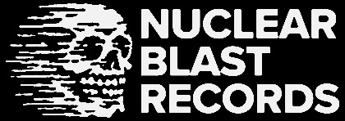

ABORTED
Vault Of Horrors

Release Date: March, 15th 2024

Line up: | ABORTED online:
Sven De Caluwé – Vocals  Ian Jekelis – Guitar  Daniel Konradsson – Guitar  Stefano Franceschini – Bass  Ken Bedene – Drums | https://goremageddon.be/  https://www.youtube.com/@abortedmetal  https://www.instagram.com/abortedmetal/  https://twitter.com/abortedmetal
Since their unholy inception in 1995, death metal miscreants ABORTED have been one of the pioneers of the genre and have annihilated friend and foe with relentless intensity and an uncompromising mix of flawless technicality and raw emotion.
Having carved a niche for themselves in the extreme metal realm, the multi-national combo around Sven de Caluwé initially gained notoriety by offering up ruthlessly fast death-grind with groovy breakdowns on their early works (The Purity of Perversion, Goremageddon: The Saw And The Carnage Done). By meticulously crafting and introducing more technical elements on more recent releases such as TerrorVision, Retrogore and ManiaCult, ABORTED has consistently sharpened their lethal blend of furious death metal. Thereby firmly cementing their status as one of the most menacing and envelope-pushing metal acts of the 21st century.
For their twelfth studio album, set to attack the living on March 15th, the band teamed up with Nuclear Blast. With each of the ten new tracks, ABORTED dives deep into the vaults of VHS cassettes and stories that have been haunting us all for decades. Each song pays tribute to a horror cult classic and ranges from obligatory cuts such as ‘The Texas Chainsaw Massacre’ (to be found on 'Death Cult’) or ‘Halloween’ (‘The Shape Of Hate’) to the more recent ‘The Mist’ to be discovered on ‘Malevolent Haze’. True to themselves, it wouldn’t be an ABORTED reference without an odious homage to none other than shit daemon ‘The Golgothan’ (sadly defeated by Silent Bob through the use of deodorant, cheeky bastard!).
There are plenty of familiar faces (and those who collect them), stories and easter eggs to be found on these ten ferocious, gut-wrenching death metal slashers.
“It’s partially personal preference, but also stories that were interesting to write about”, frontman Sven remembers the writing process and how they chose their victims from the endless arsenal of great horror films. “‘Return of the Living Dead’ was picked not because it’s an interesting story, but because it’s a movie that hasn’t really gotten any coverage from any metal band yet and it’s a great fun film. ‘The Mist’ is another great one and carries a lot of sustenance, as does ‘Prince of Darkness’. The dark world of John Carpenter is always mesmerizing.”

If you’re going head to head with the most vile and infamous monsters in pop culture (all cleverly combined into one supervillain on the cover artwork created by Dan Goldsworthy), you might as well get some help from some of the best out there, right? Therefore, ABORTED invited the crème de la crème (sadly, they ran out of ice cream) of the music scene to the party, and on each track of the album you will find a different guest vocalist – ranging from Alex Erian (DESPISED ICON) to Johnny Ciardullo (CARCOSA / ANGELMAKER), Ben Duerr (SHADOW OF INTENT), Francesco Paoli (FLESHGOD APOCALYPSE) and many more:
“As usual, the guest vocalists were all chosen out of friends, people we’ve known for years or got to know in the last years, toured with, or have a connection with. Hal from Engulf was also picked since I did a guest spot on their record and loved his vocals. The guys from Ingested, Carcosa, Ov Sulfur were people that we toured with last year. We also go way back with Archspire, Despised Icon, Fleshgod Apocalypse and Cryptopsy. Being able to collaborate with all these great artists is such a privilege and made the process all the more exhilarating since each of them bring their own flavour to the mix. The enthusiasm of everyone involved definitely shines through to the final product and adds yet another layer of depth to the listening experience of the album.”
With this deadly alliance, Vault of Horrors is an epic journey where listeners are thrust into a world of intense brutality, characterized by lightning-fast guitar riffs, intricate, pummeling drum patterns and monstrous vocals that leave no room for respite.
For the first time since 2016’s Retrogore the band opted for a full production with audio extraordinaire and heavyweight producer Dave Otero (Cattle Decapitation, Archspire, Khemmis):
“The process was different as we spent 6 weeks tracking with him. We did the pre-production with him and he was very involved with each step. In the past, we’ve had people that were less involved or only tracked drums and vocals while the guitarists did their thing. Now everyone went through Dave’s little ‘Torture Chamber' and it was a great experience. He has a vision and is simply fantastic to work with. I don’t think I’ve ever spent as much time on vocals as on this record. Dave is a fan of the music, he knew the band well and really wants to bring out what makes Aborted ‘Aborted’. He gets super excited working on the music which creates this infectious energy that makes for a really motivating atmosphere. Honestly, it was the best studio experience I’ve ever had and the result speaks for itself.”
And oh boy-o, does it! So sit back, grab a snack, and crawl down into the Vault of Horrors, if you dare. As the final notes fade, one thing will be clear – with this new release, ABORTED have not only once again proven their dominance in the world of death metal but leaped to new heights.

